**DATA VISUALIZATION ASSIGNMENT-SULEIMAN SHAMSUDEEN**

**Lesson 1 Exercise A: Observing and commenting on the use of data visualization in a presentation**

*Provide answers to each of the questions.*

1. *Describe those attributes of Hans Rosling’s presentation that you find particularly effective. Explain why.*

**ANSWER**

**Hans Rosling** is a professor of international health and director of the Gapminder Foundation. This Video is a 2005 report that visualizes (Timeseries) the changes in poverty, Income and life expectancy (Lifespan) by country over 200 years. His presentation of this facts by visuals makes a compelling story, the most effective attributes of Hans presentation are:

1. His use of story telling to show how countries have changed with respect to important world events such as the first and second World war, Spanish Flu epidemic and Great depression
2. The use of bubbles to represent each country and make it look like a race through time to the rich and healthy corner. (showing prosperity)
3. *What questions are being addressed by the presentation?*

**ANSWER**

**1-**Global health and

1. *What data is used to create the visualization?*

**ANS**

1. *What visual cues are used to represent the data?*

**ANS**

**Lesson 2 Exercise B: Applying the basic principles of design to an Excel chart**

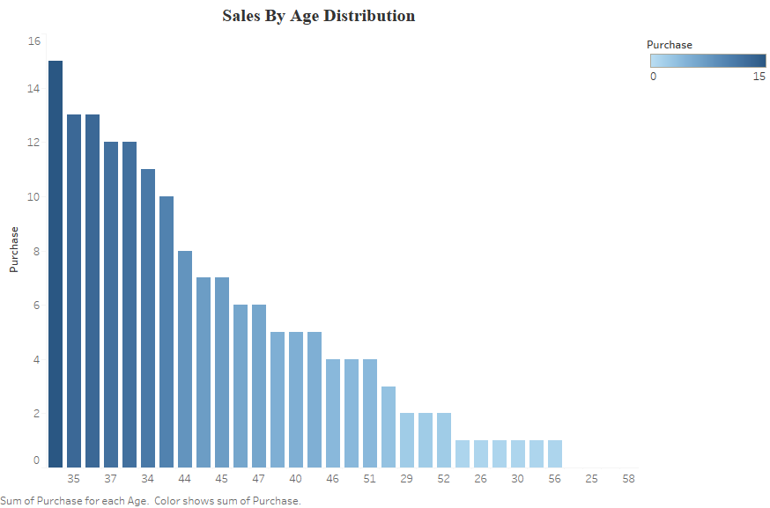

#### Lesson 3 Exercise C: Using common tools to create different displays types

